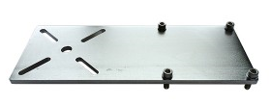

Plate Mount Model A129
260 x 100 mm (10” x 4”)
6.4 mm (¼”) thickness
Electropolished 304 stainless steel

Sturdy simple mounting solution. Secure to existing horizontal surfaces, mixing equipment, drum brackets or industrial stands. Slotted bolt pattern provides wide flexibility.

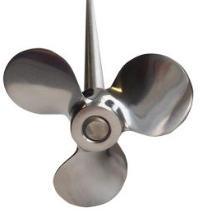

Propeller & Shaft Model A354
102 mm (4”) Ø
914 mm (36″) shaft
Axial flow

Pitched propeller made of 316L stainless steel, polished and buffed to mirror finish. 13 mm (½”) diameter shaft is welded to hub. For pilot scale and small production volume mixing. Axial flow effective for low shear mixing.

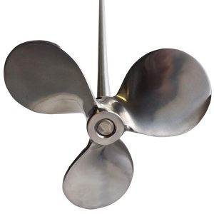

Propeller & Shaft Model A356
152 mm (6”) Ø
914 mm (36″) shaft
Axial flow

Pitched propeller of 316L stainless steel, polished and buffed to mirror finish. 13 mm (1/2″) diameter shaft is welded to hub. For pilot scale and small production volume mixing. Axial flow effective for low shear mixing.

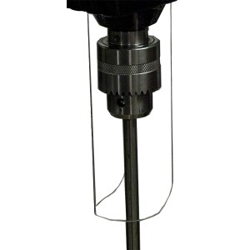

Chuck Shaft Guard Model CG6
Polycarbonate ABS
Simple bolt mounting
Safety accessory

Quickly bolts in place to create a barrier around the moving chuck and shaft, and protects the chuck from splash. Use with industrial mixer 1540.
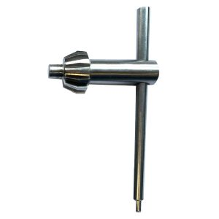

Chuck Key Only Model A016KEY
132 mm x 70 mm (5 3/16” x 2 ¾”)
Multipurpose tool
420 stainless steel

Chuck key from the A016SET. Includes hex tool for chuck installation and removal, which can also install chuck shaft guard.
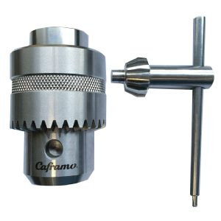

Chuck Set Model A016SET
Shaft Ø up to 16 mm (⅝”)
Through shaft
420 stainless steel

Chuck and key for Caframo Crossover mixer. Facilitates quick impeller changes or positioning. Chuck key includes hex tool for output shaft installation and easy removal for cleaning. Chuck shaft guard is available.
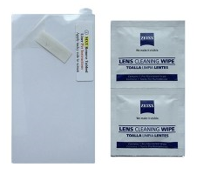

Screen Protector Model S200
61.5 x 110 mm (2.4” x 4.3”)
Self-adhesive
Resin-coated PET

Protect resistive touch screen of Caframo Crossover from splashes or dust without reducing functionality. Adhesive backing enables immediate installation and replacement.

